We know how to classify items by their temperature. Look at the items below. They are ordered from hottest to coldest.
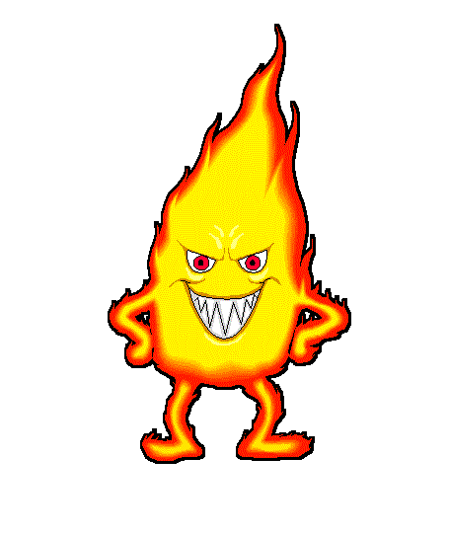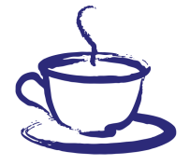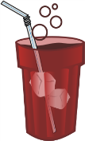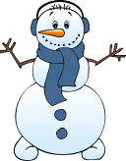
Hottest Hot Cold Coldest

Now it’s your turn. Put a number under each picture to show which one is:
1 – hottest 2 - hot 3 – cold 4 - coldest
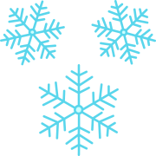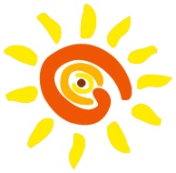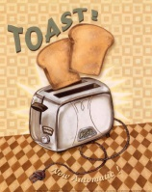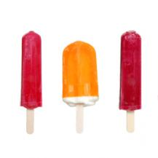

___________ ____________ ____________ ____________

Thermometers are tools used for measuring temperature. We measure temperature in Degrees Celsius. Looking at the scale along the stem of the thermometer tells us how hot or cold something is. For example, the mercury in this thermometer is showing 0 Degrees Celsius (the freezing point of water).
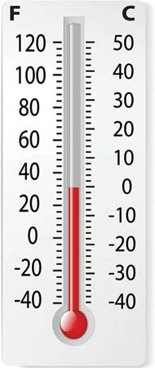
Scale
Stem
Current temperature
Bulb

Now it’s your turn. What temperature are these thermometers showing?
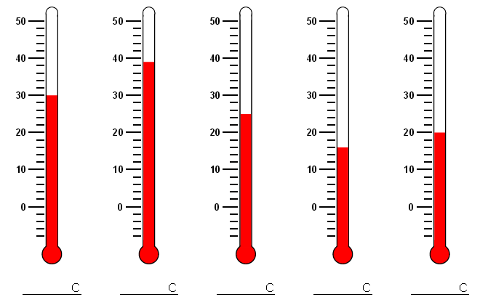
When temperatures are very high or very low, it is important we take care of ourselves and stay safe. If mum has a hot cup of tea, we must be careful not to knock it over. If we are playing out in the sun on a hot day, we should drink plenty of water.
Now it’s your turn. Write a safety rule for:
The oven: ______________________________________________________________________________________.
Playing in the snow: __________________________________________________________________________.

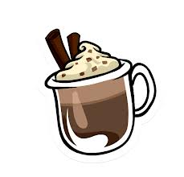
An insulator is something that stops or decreases the transfer or leakage of heat or cold. Fur, blubber, ice boxes, a thermos, a scarf and a jacket are all insulators.

What would be the best insulator to keep this hot chocolate warm?
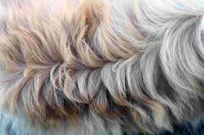
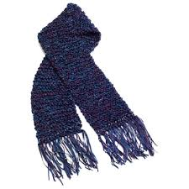
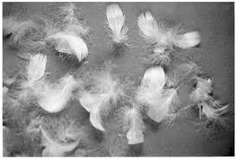
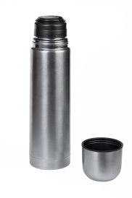

Heating or cooling objects often changes them. For example, toasting bread changes it from soft and white, to crunchy and brown. Some changes are permanent. The thing can never be changed back into what it was before. Burning wood in a fire is an example of how heat changes something that can never be changed back.
How does heating sugar change it?
______________________________________________________________________________________ 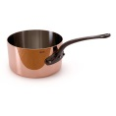
Can the change be reversed? (Circle one) Yes No
How does freezing water change it?
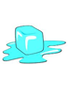
______________________________________________________________________________________
Can the change be reversed? (Circle one) Yes No

There are many ways to change the temperature around us. If we are too cold we could light a fire or turn on a heater. If our classroom is too hot, how could we make it cooler?

We cannot always change the temperature around us. Then, we have to make other changes. If it is a very hot day we could go for a swim. How can an animal (like a polar bear or whale) keep themselves warm? _______________________________________________________________________________________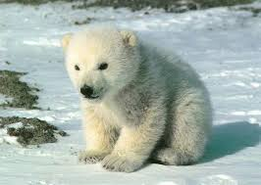

If you were cold at recess, the best colour to wear would be (Circle one): Black White

If you are sick, your body temperature goes (Circle one): Up Down Stays the same

