Rules for Measurement
- Your units of measure - what you are measuring with (e.g. paperclips, coins or toy cars) must touch, without any spaces in between (Note: we are not learning about standard measures like centimeters or meters yet).
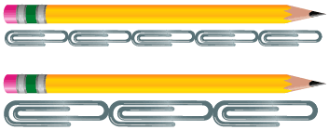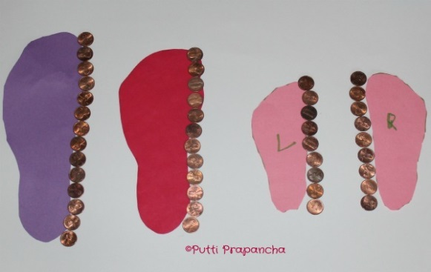

- Make sure you measure from end to end.
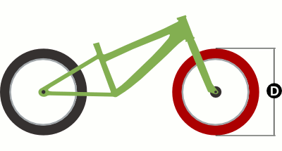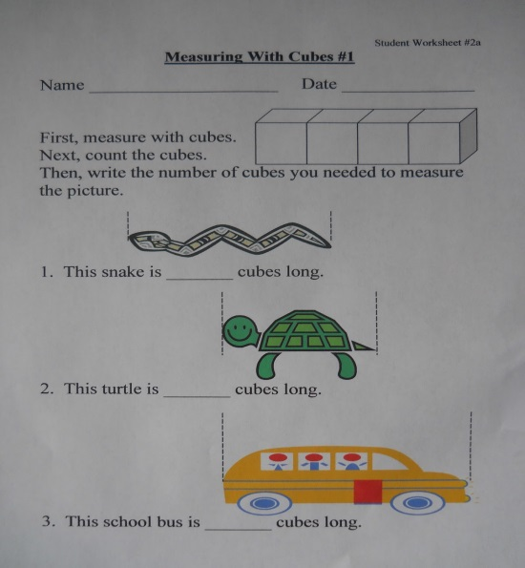

- Measure in a straight line.
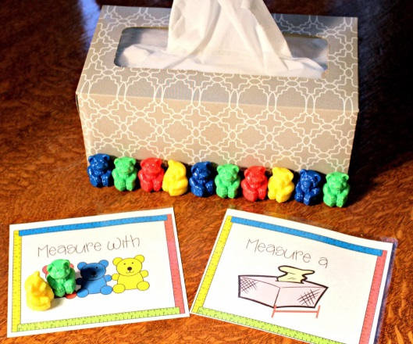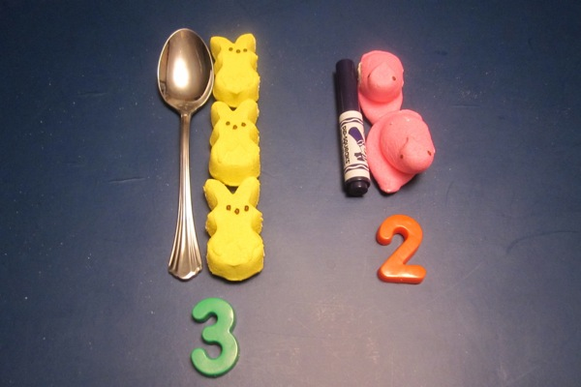

- Do not mix units of measure. Use all the same objects.
