A pattern is a grouping of things that repeats. Once we know what the core of the pattern is, we can predict what comes next.
The pattern core is the part of the pattern that is repeated over and over again. True patterns have a core that repeats at least 3 times. The core in the pattern below has been circled for you:

A B A B A B A B
We can name our patterns to make it easier to find the core and to describe the pattern. Patterns are usually named with letters of the alphabet (e.g. A, B, C etc.) The core of this AABBBCCD pattern is:
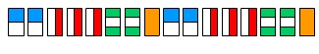
A A B B B C C D A A B B B C C D

Now it’s your turn. What is the core in the following pattern?

A B C A B C A B C

Attributes are features that you can describe. They show how each pattern element (or individual piece) is different. Elements can differ due to many things like shape, size, direction or colour. The attributes in the following pattern are Shape (butterfly shape, dragonfly shape, ant shape) and colour (purple, blue, black). This pattern has 2 attributes.
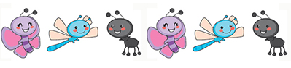
B C A B C

Shape, size and colour do not change in the pattern below. It has only 1 attribute – direction. The key faces different ways.
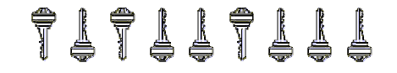
A B A B B A B B B
Now it’s your turn: What are the 2 attributes in this pattern?

A B C A B C A B C

Increasing patterns are patterns that get bigger or grow. The following is an example of a growing pattern. The pattern increases by 3 each time.
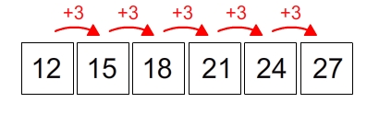
Pattern rules describe how increasing patterns grow. The following pattern grows by 1 button each time. The pattern rule is + 1.
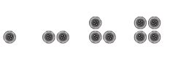
Now it’s your turn. Is this an increasing pattern? What is its pattern rule?
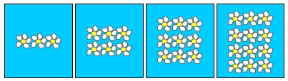
Here is another increasing pattern. The pattern rule is +2. Can you fill in the missing addition sentences to explain the pattern rule?
