Buoyancy and Boats- Unit Review
- Buoyant: How well something floats (Buoyancy is an upward force in water).

- If something is heavier than the water it is in (more dense) or isn’t full of air, it will sink (like a rock or a paper clip).

- If something is lighter than the water it is in (less dense) or is full of air, it will float (like an orange with the peel on or a piece of Styrofoam – they are full of pockets of air).

- Stability: How steady and balanced a boat is. A stable boat is less likely to tip over.

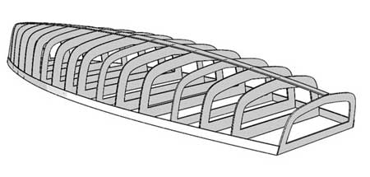
- Hull: The hull is the body of the boat.

- A wider hull makes a boat more stable. A long, skinny hull (like a canoe) makes a boat less stable.
- Two hulls (like a catamaran) makes a boat more stable.
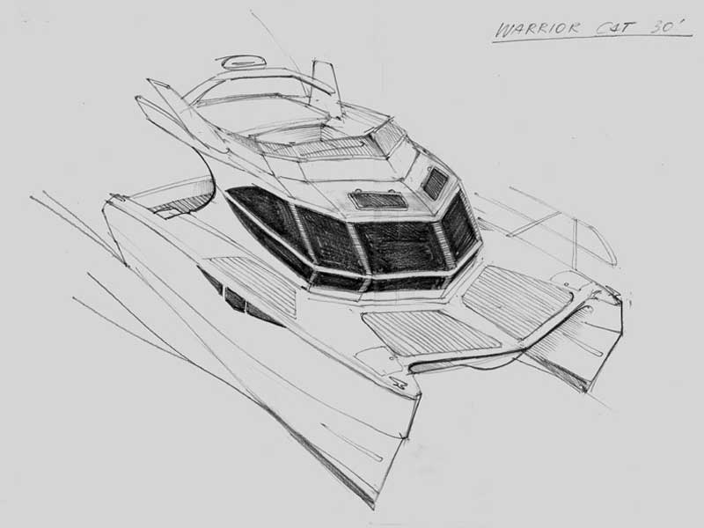

- Keel: Putting a weight at the bottom of a boat (a keel) helps the hull move forward, not slip to the side. Keels have weight inside to make them heavier so the boat is more stable. These boats all have keels. Can you draw a keel on a boat?
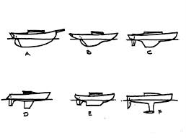

- Cargo and stability: You must balance the cargo on a boat or it will not be stable. Cargo should be placed in the middle or in equal amounts on either side.

- Look at this picture. Which Koala is in the best position to keep the boat stable?
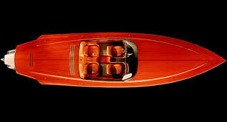
Prince



Zelda

Maggie

- Buoyant forces: There are opposite forces at work when we think about buoyancy.
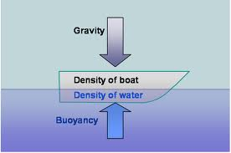

Gravity pushes down and Buoyancy pushes up.
- Waterproof: Some materials repel water (are waterproof). They are the best materials to make boats out of.

- Look at this list. Which of these materials are waterproof?

- Rubber boot
- T-shirt
- Styrofoam
- Carpet
- Paper
- Sticky tape
- Straw
- Kleenex
- Sponge
- Foil
- Plastic
- Cardboard
- Tissue roll
- Metal

- Seals and Bonds: Some materials work better to hold boats together. Sealing closes up gaps and holes in a boat. Bonding means sticking things together.

- Sticky tape and glue are not good for bonding or sealing boats. They fall apart in water. Plasticine, pipe cleaners and rubber bands hold together better in water.
- You can change an object that sinks (a sinker) to make it float by changing its density. Think about the rocks and the egg we experimented on in class, and the life jackets people wear to keep them safe if they fall out of their boat.

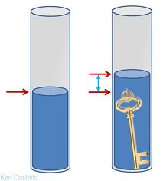
- Displacement: When you put something in water, the space taken by the object will move the water level up by the same amount. Remember Archimedes and his bath!

- A boat needs to have high walls (or be super buoyant – like a raft), be waterproof and stable, be able to carry a load, have a wide enough bottom to be lighter than the water (less dense) and be full of air (this lowers its density).

- What are boats for? Boats are used for:
- Travelling across water
- Gathering food
- Safety and rescue
- Fun
- Water sports
- Moving cargo
- Moving people
- Moving animals

- How do boats move? Boats move with the wind (sail boats), by being paddled (paddle steamers), with oars (row boats, canoes and kayaks), or with an engine and a propeller (speed boat or container ship).

